Briansclub: A Hidden Gem in the World of CV2 Fullz Dumps

Introduction to Briansclub CV2 Fullz Dumps Shops and the underground world of online fraud
In the vast landscape of the internet, where individuals from all corners of the world connect and transact, there exists a hidden gem in the underbelly of this digital realm. Welcome to Briansclub - a notorious CV2 Fullz Dumps Shop that has carved its name into the annals of online fraud. Brace yourself as we embark on a journey to unearth the secrets behind this shadowy empire and explore how it has risen to become one of the most popular destinations for illicit activity on the black market.
With cybercrime running rampant in today's society, it comes as no surprise that platforms like Brlanclub.com have gained notoriety among those seeking financial gain through illegal means. But what exactly is Briansclub? How does it operate? And what impact does it have on both our economy and unsuspecting consumers? Join us as we delve deep into these questions and uncover just how this underground kingdom thrives amidst an ever-evolving cybersecurity landscape.
But beware! As with any operation shrouded in secrecy and controversy, Briansclub has found itself embroiled in legal battles that threaten its very existence. We'll also shine a light on these controversies, exploring both sides of the coin to paint a comprehensive picture of this enigmatic entity.

The rise of Briansclub and its popularity in the black market
The rise of Briansclub in the black market is a testament to the ever-evolving world of online fraud. With its wide array of stolen credit card data and impeccable reputation for delivering high-quality goods, this underground CV2 Fullz Dumps Shop has become a go-to destination for cybercriminals seeking financial gain.
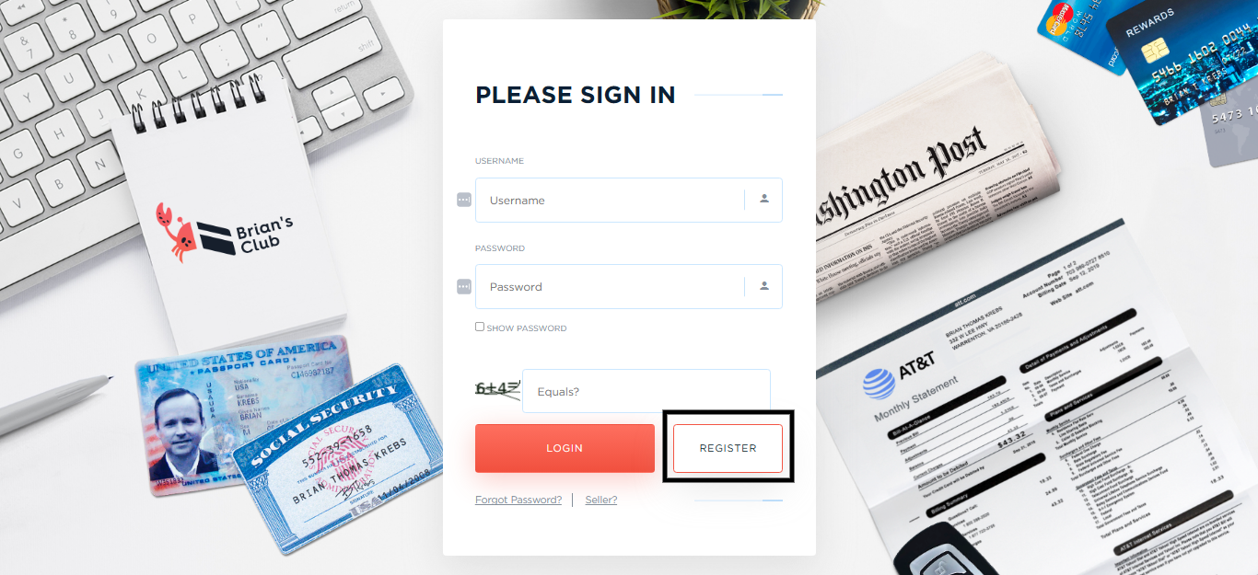

A Screenshot of Brlanclub.com Login Page
Brlanclub.com popularity can be attributed to several factors. It boasts an extensive database of compromised payment information from around the globe. This vast collection includes not only credit card details but also personal identification numbers (PINs), making it a one-stop shop for criminals looking to make fraudulent purchases or cash withdrawals.
Moreover, Briansclub prides itself on its customer service and reliability. Potential buyers can browse through various categories such as gold cards or platinum cards, each with different purchasing power and associated risks. The shop also offers escrow services to ensure transactions are secure, giving buyers peace of mind when conducting illicit business.
The growing demand for stolen credit card data has fueled Briansclub's ascent in the black market economy. As more people turn to online shopping and digital payments, cybercriminals have found lucrative opportunities to exploit vulnerabilities in these systems. With millions of dollars at stake, Briansclub has positioned itself as a trusted supplier within this thriving criminal ecosystem.
However, it is important to note that using Briansclub or any other similar platform comes with significant legal consequences and ethical implications. Engaging in illegal activities not only harms innocent victims but also perpetuates an industry built on deceit and theft.

How Briansclub operates and its impact on the economy and consumers
Brlanclub.com operates as an online marketplace for stolen credit card information, catering to a vast network of cybercriminals. This underground platform has gained significant popularity in the world of online fraud due to its wide range of offerings and efficient operations.
The way Briansclub works is quite straightforward. It sources stolen credit card data from various hacking activities and then sells this information on its website. Buyers can browse through different categories such as country, bank, and card type to find the specific details they are looking for. Once a purchase is made, the buyer receives access to the compromised credit card details, including the card number, expiration date, CVV code, and sometimes even personal information like name and address.
The impact of Briansclub on both the economy and consumers cannot be underestimated. On one hand, it fuels illegal transactions by providing cybercriminals with ready-to-use financial credentials. This leads to a direct loss in revenue for banks and businesses that fall victim to fraudulent purchases or chargebacks.
On the other hand, consumers bear the brunt of these illicit activities as their hard-earned money becomes vulnerable to unauthorized charges or identity theft. The repercussions extend beyond immediate financial losses; victims may also suffer long-term damage to their credit scores or face difficulties resolving fraudulent transactions.
Moreover, Brlanclub.com operations indirectly contribute to an overall erosion of trust in e-commerce platforms. With every successful transaction carried out using stolen credit cards purchased from such sites, consumer confidence takes another hit.
Law enforcement agencies worldwide have been actively working towards shutting down operation hubs like Briansclub due to their detrimental effects on society. However,
the cat-and-mouse game between authorities and cybercriminals continues unabated.

Controversies surrounding Briansclub and its legal battles
Controversies surrounding Briansclub cm and its legal battles have been a constant topic of discussion in the underground world of online fraud. As one of the most popular CV2 Fullz Dumps Shops, it has faced numerous challenges and legal actions over the years.
One major controversy revolves around the legality of Briansclub's operations. Law enforcement agencies worldwide have been cracking down on cybercriminals involved in credit card fraud, leading to multiple arrests and shutdowns of similar platforms. However, Briansclub seems to continuously adapt and find ways to evade detection, making it difficult for authorities to completely shut it down.
Another controversy stems from the impact that CV2 Fullz Dumps Shops like Briansclub have on consumers. With stolen credit card information readily available for purchase on such platforms, innocent individuals often fall victim to identity theft and financial loss. This not only affects individual victims but also damages trust in online transactions as a whole.
Furthermore, there is an ongoing debate about whether or not law enforcement agencies should focus their efforts solely on shutting down these illegal operations or if they should also target the buyers who fuel the demand for stolen credit cards through platforms like Briansclub.
In addition to legal battles with law enforcement agencies, Briansclub has also faced internal struggles within its own community. Competitors may try to discredit or disrupt its operations by spreading rumors or launching cyber-attacks against its infrastructure.
Despite all these controversies and legal battles, Briansclub continues to thrive in the shadowy corners of cyberspace. Its resilience and ability to adapt highlight both the sophistication of today's cybercriminals as well as the challenges faced by those working tirelessly to combat them.
As long as there is a demand for stolen credit card information, platforms like Briansclub will likely continue operating under various guises with ever-evolving tactics aimed at staying one step ahead of law enforcement. The future remains uncertain for both sides in this ongoing cat-and-mouse game between criminals and those seeking to bring them to justice.

The future of Briansclub and the carding industry
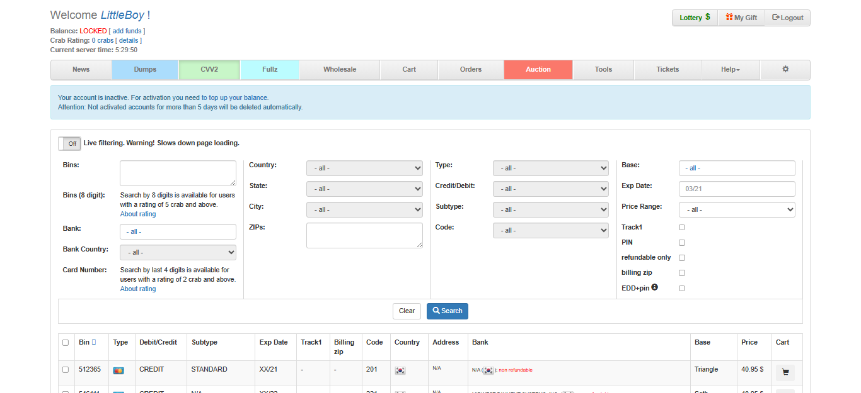
A Screenshot of Brlanclub.com CVV2 Dumps Page

The future of Briansclub and the carding industry is undoubtedly shrouded in uncertainty. As law enforcement agencies continue to crack down on cybercrime, these underground operations face increasing pressure to adapt and evolve. However, it would be naive to assume that this will lead to their complete extinction.
With advancements in technology and the ever-growing reliance on online transactions, there will always be a demand for stolen credit card information. As long as there are criminals willing to exploit vulnerabilities in the system, CV2 Fullz Dumps Shops like Brlanclub.com will find ways to thrive.
However, it's important to note that the landscape is changing. The emergence of more secure payment methods such as two-factor authentication and biometrics could potentially make it harder for carders to operate undetected. Additionally, financial institutions are becoming more proactive in monitoring suspicious activities and implementing stricter security measures.
Furthermore, international cooperation among law enforcement agencies is steadily improving, making it increasingly difficult for these illegal enterprises to stay under the radar. This means that while Briansclub may still have some time left before its eventual demise or transformation into something else entirely, its days are likely numbered.
In conclusion (without stating "in conclusion"), one thing is certain - online fraud will continue to exist in some form or another. Whether it's through traditional CV2 Fullz Dumps Shops like Briansclub or new innovative methods yet unknown, cybercriminals are a persistent threat that society must remain vigilant against. It falls upon individuals and organizations alike to take steps towards enhancing cybersecurity measures so that we can protect ourselves from falling victim to these illicit activities.

Tips for protecting yourself from online fraud
The world of online fraud is constantly evolving, with new tactics and techniques being employed by cybercriminals every day. In order to protect yourself from falling victim to these scams, it's important to stay vigilant and take proactive measures. Here are a few tips for safeguarding your personal information and financial security:
1. Strengthen your passwords: One of the simplest yet most effective ways to protect yourself online is by using strong, unique passwords for each of your accounts. Avoid common phrases or easily guessable combinations, and consider using a password manager to securely store your credentials.
2. Enable two-factor authentication (2FA): Many websites now offer 2FA as an additional layer of security. By enabling this feature, you'll need more than just a password to access your account – typically a verification code sent to your phone or email.
3. Be cautious with public Wi-Fi: Public Wi-Fi networks can be hotspots for hackers looking to intercept sensitive data. Whenever possible, avoid accessing personal accounts or conducting financial transactions while connected to public networks.
4. Keep software up-to-date: Regularly updating your operating system and applications ensures that you have the latest security patches installed, closing any vulnerabilities that may be exploited by cybercriminals.
5. Practice safe browsing habits: Be wary of clicking on suspicious links or downloading files from unknown sources. Install reputable antivirus software on all devices and regularly scan for malware.
Remember, no precaution is foolproof when it comes to protecting against online fraud, but taking these steps can significantly reduce the risk of becoming a victim. Stay informed about emerging threats in the digital landscape and always prioritize the safety of your personal information!

Conclusion: Is it worth the risk to use CV2 Fullz Dumps Shops like Briansclub
As we conclude our exploration of Briansclub and the underground world of online fraud, it is important to address the question that looms over this controversial topic: Is it worth the risk to use CV2 Fullz Dumps Shops like Brians club?
While some may be enticed by the allure of easy money and access to stolen credit card information, it is crucial to consider both the ethical and legal implications. Engaging in illegal activities such as credit card fraud can have severe consequences, including criminal charges, fines, and even imprisonment.
Furthermore, utilizing a CV2 Fullz Dumps Shop like Brlanclub.com not only supports an industry built on deception but also perpetuates a cycle of financial losses for innocent individuals who fall victim to these crimes. The impact on businesses and consumers alike cannot be underestimated.
It is essential for individuals to prioritize their personal security when engaging in any online transactions or activities. Protecting your sensitive information through strong passwords, secure payment methods, and regular monitoring of your financial accounts can go a long way in safeguarding yourself against potential threats.
In today's digital age where cybercrime continues to evolve at an alarming rate, staying informed about potential risks is key. Educating oneself about different scams and fraudulent schemes empowers individuals with knowledge that can help them make better-informed decisions while navigating cyberspace.
Each person must weigh the potential rewards against the significant risks involved in using CV2 Fullz Dumps Shops like Briansclub. It is crucial to remember that crime does not pay off in the long run – both morally and legally.
Instead of seeking shortcuts or engaging in unlawful activities that harm others financially or emotionally, let us focus on fostering a safer online environment for everyone. By promoting honesty, integrity, and responsible behavior online, we contribute towards building a more trustworthy digital landscape where business transactions can thrive securely without compromising anyone's well-being.

Frequently Asked Questions (FAQ’s)

What is Briansclub and how does it operate in the world of online fraud?
Briansclub is an online platform that offers a comprehensive database of compromised credit card information for sale. This information is obtained through various forms of cybercrime such as hacking or phishing scams. The data on Brlanclub.com is constantly updated, making it a prime source for cybercriminals looking to make fraudulent purchases or engage in identity theft.

Can you explain the concept of CV2 Fullz Dumps Shops and what role Briansclub plays in this underground market?
CV2 Fullz Dumps Shops are essentially websites that sell stolen credit card information and other personal data. These shops operate on the dark web, making it difficult for authorities to track them down. Brlanclub.com is one of the largest and most notorious CV2 Fullz Dumps Shops, with a vast selection of stolen credit card data from all around the world. Their services allow criminals to make fraudulent purchases and identity theft, causing millions of dollars in losses each year.

How can users benefit from using Brlanclub.com services?
Users of Briansclub can benefit in multiple ways. Firstly, our platform offers a wide range of services that cater to different needs and interests. Whether you are looking for educational programs, career coaching, or legal advice, Briansclub has got you covered. Our highly trained and experienced experts provide personalized support and guidance tailored to your unique goals and preferences.

Are there any risks associated with engaging with a CV2 Fullz Dumps Shop like Briansclub?
While we cannot guarantee 100% safety, Briansclub takes security seriously and implements multiple measures to protect our clients. Our website is encrypted with SSL technology, keeping your information safe from hackers. Additionally, all transactions are processed through secure and trusted payment gateways. However, it is important to be cautious and practice safe online habits when engaging with any type of online marketplace or shop.

Is it legal to participate in activities related to carding or use services provided by platforms like Briansclub?
We here at Brlanclub.com do not encourage nor condone any illegal activities. It is important to always follow the laws and regulations in your country or state regarding carding. However, we do offer a platform for users to educate themselves on the topic and learn about potential risks associated with carding.

How does Briansclub ensure the safety and security of user information during transactions?
At Briansclub, we take the security and privacy of our users very seriously. We use industry-leading encryption technology to protect all sensitive information during transactions, including personal and financial data. Our payment processing system is also PCI compliant, ensuring that your credit card information is secure and protected at all times.

Can you provide examples of the types of products or services available through Brlanclub.com and how they are obtained?
Through Briansclub, you can access a wide range of exclusive products and services that are curated specifically for our members. These include luxury items such as designer clothing, accessories, and electronics, as well as unique experiences like VIP event tickets or private travel packages.

As a potential user, what precautions should I take if I choose to engage with websites or platforms involved in carding activities, such as yours at Briansclub?
As with any online transaction, it is important to exercise caution and awareness. At Brlanclub.com, we take our user's security seriously and have implemented measures to protect your personal information. However, it is always recommended to make sure that you are using a secure internet connection and to never share sensitive information, such as credit card numbers or login credentials, with anyone.

